Statement of Dr. Steven M. Fortier
Director, National Minerals Information Center
U.S. Geological Survey
before the
Senate Committee on Energy and Natural Resources
on
July 17, 2018
Good morning Chairman Murkowski, Ranking Member Cantwell, and Members of the Committee, and thank you for the opportunity to discuss the U.S. Geological Survey’s efforts related to critical minerals.
Background
The Department of the Interior manages one-fifth of the Nation’s lands, as well as the Nation’s offshore energy. These responsibilities include leasing and permitting activities for both onshore and offshore access to and development of the Nation’s mineral resources, through the Bureau of Land Management (BLM) and the Bureau of Ocean Energy Management. The U.S. Geological Survey (USGS) conducts scientific research on how mineral resources form geologically, provides earth-science based assessments on the geologic potential for mineral commodity occurrences across the Nation and globe, and provides statistics on the worldwide supply, demand, consumption, and flow of mineral commodities essential to the Nation’s economy and national security.
Reliance on Foreign Sources of Minerals
USGS data show that domestic and global demand for mineral commodities continues to increase. An increasingly broad range of mineral commodities are used in consumer and national security applications , especially those involving advanced technologies. The United States remains a major mineral producer with an estimated total value of non-fuel mineral resources of $75.2 billion in 2017, and is a net exporter of 16 non-fuel mineral commodities. However, our country continues to rely on foreign sources for some raw and processed mineral materials. In 2017, the country was 100 percent import-reliant for 21 mineral commodities. For comparison, in 1984, the country was 100 percent import-reliant for just 11 mineral commodities. Furthermore, the country was at least 50 percent import-reliant for 50 mineral commodities in 2017. Figures 1 and 2 provide an overview of these import sources, and show that China, followed by Canada, supplied the largest number of nonfuel mineral commodities for which the U.S. is more than 50 percent import reliant.
This dependency of the United States on foreign sources creates the potential for strategic vulnerabilities for the Nation’s economic and national security interests, to adverse foreign government actions, natural disasters, or other events that can disrupt supply of important minerals.
Figure 1. 2017 U.S. net import reliance, expressed as a percentage of apparent consumption. (Source: USGS Mineral Commodity Summaries 2018.)

Figure 2. Major import sources of non-fuel mineral commodities, shaded to indicate the number of commodities for which the United States was more than 50 percent net import reliant in 2017. (Source: USGS Mineral Commodity Summaries 2018.)
A New Whole-of-Government Strategy
On December 20, 2017, President Trump issued Executive Order 13817, “A Federal Strategy to Ensure Secure and Reliable Supplies of Critical Minerals”. The Executive Order directed the Federal Government to develop an interagency report, to include:
(i) a strategy to reduce the Nation’s reliance on critical minerals;
(ii) an assessment of progress toward developing critical minerals recycling and reprocessing technologies, and technological alternatives to critical minerals;
(iii) options for accessing and developing critical minerals through investment and trade with our allies and partners;
(iv) a plan to improve the topographic, geologic, and geophysical mapping of the United States and make the resulting data and metadata electronically accessible; and
(v) recommendations to streamline permitting and review processes related to developing leases; enhancing access to critical mineral resources; and increasing discovery, production, and domestic refining of critical minerals.
The Department of the Interior is contributing to several aspects of the report, with the Department of Commerce responsible for the overall report. Additional interagency contributions are being coordinated through the White House Office of Science and Technology Policy’s National Science and Technology Council (NSTC) Subcommittee on Critical and Strategic Mineral Supply Chains. I’ll describe some of the steps that USGS has taken in response to the Executive Order, and then discuss our approach to identifying critical minerals.
The Executive Order directed the Secretary of the Interior, in coordination with the Department of Defense and in consultation with other executive branch agencies, to publish a list of critical minerals. Under Department of the Interior Secretarial Order 3359, the USGS, in coordination with the BLM and with broad Federal interagency input, led development of the critical minerals list; this list will guide the focus of the Commerce-led report.
The USGS is also leading development of a plan to improve the Nation’s mapping and understanding of subsurface mineral resources (item iv above), with input from agencies with both onshore and offshore mapping responsibilities (including USGS science and mapping programs, the Bureau of Ocean Energy Management, the National Oceanic and Atmospheric Administration, and the Department of Energy), and anticipated partnerships with states. The plan aims to improve the Nation’s geophysical, geological and topographic mapping, building on existing national maps to create modern maps based on the newest technologies and science. USGS data collection, analysis and interpretation greatly enhances our understanding of the Nation’s geological endowment of critical minerals, and directly benefits our understanding of other economically valuable mineral resources, energy resources, groundwater resources, geologic hazards, infrastructure dependencies on subsurface geology, and other societal needs.
In addition, the USGS is contributing technical input to the report in response to the Executive Order on the geologic composition of above-ground sources of minerals such as mine wastes and other waste streams; and on global production and trade statistics for mineral commodities.
Identifying Minerals as “Critical”
Federal agencies and other organizations use a number of existing definitions and criteria to identify a material or mineral as “critical”, “strategic”, or otherwise important. The Executive Order defined a critical mineral as (i) a non-fuel mineral or mineral material essential to the economic and national security of the United States, (ii) the supply chain of which is vulnerable to disruption, and (iii) that serves an essential function in the manufacturing of a product, the absence of which would have significant consequences for the U.S. economy or national security.
To identify minerals meeting the definition of criticality under the Executive Order, the USGS used as a starting point a screening tool developed in 2016 and updated in 2017, by the NSTC Subcommittee. The NSTC Subcommittee has representation from Federal Departments including, but not limited to, Defense, Interior, Energy, State, Commerce, and Homeland Security. This interagency engagement resulted in a tool that drew from the contributing agencies’ existing prioritization processes, and represents a range of Federal agency missions and understanding of industries. The tool is a quantitative methodology for identifying and ranking mineral commodities based on widely accepted criteria published in the mineral commodity literature. Using that methodology, and several other sources of data, the USGS applied two principal quantitative criteria to evaluate minerals for inclusion on the draft list of critical minerals: the Herfindahl-Hirschman index, which measures country concentration of production, and the USGS net import reliance metric based on USGS’s annual Mineral Commodities Summaries.
The Secretary of the Interior published a draft list of critical minerals in the Federal Register on February 16, 2018, accepted public comment for 30 days ending March 19, 2018, and received more than 450 comments, which are available at regulations.gov (https://www.regulations.gov/document?D=DOI-2018-0001-0001). After reviewing the comments, the Department of the Interior finalized the list in a second Federal Register notice on May 18, 2018. The list of critical minerals, while “final,” is not a permanent list, but is dynamic and will be updated periodically to reflect current data on supply, demand, and concentration of production, as well as current policy priorities. The list consists of 35 minerals or mineral groups: Aluminum (bauxite), antimony, arsenic, barite, beryllium, bismuth, cesium, chromium, cobalt, fluorspar, gallium, germanium, graphite (natural), hafnium, helium, indium, lithium, magnesium, manganese, niobium, platinum group metals, potash, the rare earth elements group, rhenium, rubidium, scandium, strontium, tantalum, tellurium, tin, titanium, tungsten, uranium, vanadium, and zirconium. Figure 3 provides an overview of these critical minerals’ major uses at the sector level and trade dependencies at the country level.
This list of critical minerals does not include a number of economically significant minerals, such as copper, zinc, molybdenum, gold, silver; and industrial minerals such as phosphate rock, sand, gravel, and aggregates that are produced domestically in large quantities. Given current levels of domestic production, the U.S. is not highly reliant on imports for these minerals and typically has a combination of domestic reserves and reliable foreign sources adequate to meet foreseeable domestic consumption requirements. While these minerals do not currently meet the definition of critical, they are important to a modern society for the purposes of national security, technology, infrastructure, and energy production from both fossil fuels and renewable energy generation.
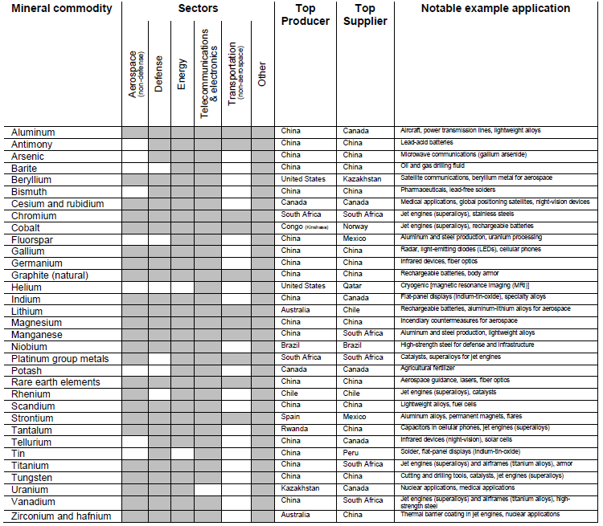
Figure 3. The 2018 list of critical minerals, as defined by Executive Order 13817.
Input from other agencies represented on the NSTC Subcommittee emphasized that uranium, while primarily used as a fuel mineral, also has important non-fuel uses related to national security, such as radiation shields, counterweights, and armor piercing kinetic energy penetrators. In addition, Energy Information Administration data indicate high production concentration and significant import reliance. Based on these factors, uranium meets the criteria for inclusion on the 2018 list.
Of the 35 minerals deemed critical, 12 are commodities recovered during the processing, smelting, or refining of a host material and are, therefore, deemed “byproducts.” For example, rhenium is recovered as a byproduct of smelting copper-molybdenum ores. Similarly, helium is a byproduct of natural gas production.
Conclusion
The USGS is actively working to support the Executive Order through our minerals science and mineral information. We appreciate the strong engagement of Congress, other Federal agencies, and of the coordinating roles played by the White House Office of Science and Technology Policy, Council on Environmental Quality and the National Economic Council.
Thank you for the opportunity to present on behalf of the U.S. Geological Survey on the important subject of critical minerals. I will be happy to answer any questions.

U.S. Geological Survey, 2018, Mineral Commodity Summaries 2018, 200 pp, https://minerals.usgs.gov/minerals/pubs/mcs/
In descending order of import share.
White House Office of Science and Technology Policy, National Science and Technology Council, 2016, “Assessment of critical minerals: screening methodology and initial application”, https://www.whitehouse.gov/sites/whitehouse.gov/files/images/CSMSC%20Assessment%20of%20Critical%20Minerals%20Report%202016-03-16%20FINAL.pdf
EA McCullough and N Nassar, 2017, “Assessment of critical minerals: Updated application of an early-warning screening methodology”, in Mineral Economics 30(3), https://pubs.er.usgs.gov/publication/70191019
The methodology used by the USGS is published in USGS Open-File Report 2018-1021, https://pubs.usgs.gov/of/2018/1021/ofr20181021.pdf
Draft List of Critical Minerals, 83 FR 7065, https://www.federalregister.gov/documents/2018/02/16/2018-03219/draft-list-of-critical-minerals
Comments received are available at https://www.regulations.gov under docket DOI-2018-0001.
Final List of Critical Minerals 2018, 83 FR 23295, https://www.federalregister.gov/documents/2018/05/18/2018-10667/final-list-of-critical-minerals-2018

