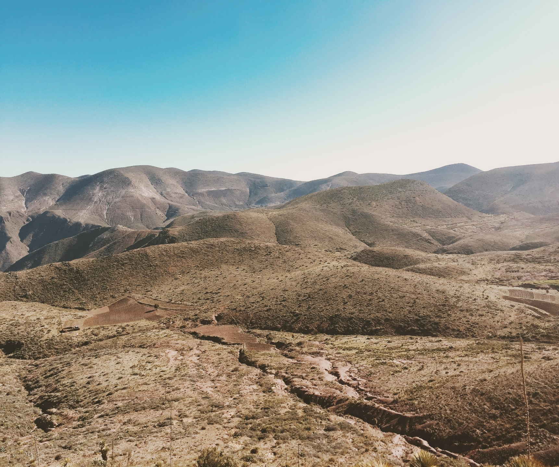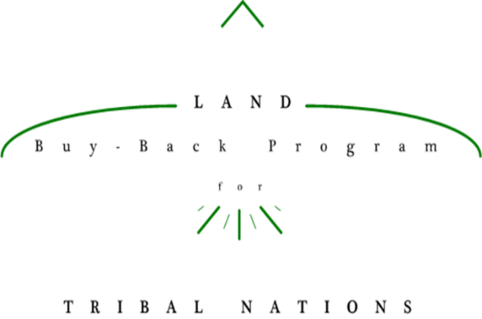

Must receive Tribal approval to use crest/seal. If not approved use Buy-Back logo.

**The <Tribe Name> invites interested landowners to learn more about their land and participation in the Land Buy-Back Program.**

**<Name of Event>**

<Date of Event>

<Time Of Event>

<Location of Event>

***<Refreshments will be served! Or other description of additional items>***

**If you cannot make the event, make sure your account information is up to date by calling the Trust Beneficiary Call Center at 1-888-678-6836.**

<SAMPLE IMAGE ONLY>

**Land Buy-Back Program**

**for Tribal Nations**

**Coming Soon!**

<Insert Tribal Crest/Seal>