Interior’s Office of Policy Analysis Seminar
Wildland Fire and Invasive Species – Strategic Opportunities

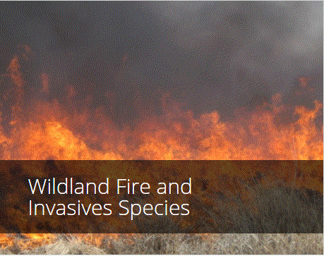

Moderator: Hilary Smith, DOI Office of Policy Analysis

Panelists:
- Wildland Fire Leadership Council, Mike Zupko
- National Invasive Species Council, Stas Burgiel
- Office of Wildland Fire (DOI), Kristy Swartz
- Bureau of Land Management, Michele Crist
- U.S. Forest Service, Rob Progar
Topic: Wildland Fire and Invasive Species – Strategic Opportunities
Date: November 8, 2021
Time: 12:15-1:45 pm (Eastern)

Webcast Only: Microsoft Teams Live Event (You can also use this link to access the recorded seminar after the event.)

Closed Captioning (CC) is available. Just click the CC button on the viewer that comes up on Teams.

The magnitude of the 2020 fire year heightened awareness of the Nation’s wildfire crisis. In many areas, the spread of invasive plants has contributed to an increase in the size, frequency, and severity of wildfires. Addressing the intertwined dynamics of wildland fire and invasive species requires understanding the underlying science and ecology, as well as the relevant institutions and effective management strategies. This includes the ability to work at different stages of the fire and invasive species management cycles: proactive pre-fire planning and fuels treatment, wildfire response, and post-fire stabilization and restoration. It also requires addressing cross-cutting and foundational issues such as data and information management, research and development, training, and funding mechanisms. This approach can provide a lens for better integrating coordination mechanisms and setting joint strategic priorities between the invasive species and fire management communities at national, regional, and local scales. The panel will discuss how to better integrate these efforts at different scales and through the collaborative initiatives.
To view the Live Event, please click on the link above. Join 5-10 minutes early to avoid technical difficulties.
To view the recorded event, please click on the link above (following the event).
The public is welcome to join the Microsoft Live (or recorded) Teams Event.
Interior Department Registrants Only: This seminar meets one hour of Executive Education training. To document your attendance, preregister via DOI Talent. Be sure to return to DOI Talent to mark yourself following the seminar.
For additional information about this event, please contact Malka Pattison at malka_pattison@ios.doi.gov

