Department of the Interior (DOI), Office of Policy Analysis Seminar
Economic Revitalization of Abandoned Mine Land: A Focus on the Appalachian Region
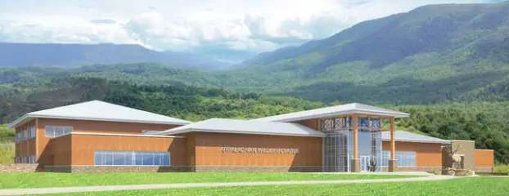
The Appalachian Wildlife Foundation’s Boone’s Ridge Project, Bell County Kentucky

Panelists:
Yolande Norman-Moore, Chief Reclamation Support Division, Office of Surface Mining, Reclamation, and Enforcement (OSMRE), DOI
Mark Gehlhar, Senior Economist, Regulatory Support Division, OSMRESathiyan Sivakumaran, Program Analyst Reclamation Support Division, OSMRE
Sathiyan Sivakumaran, Program Analyst Reclamation Support Division, OSMRE
Lee Winkler, Senior Research Analyst, Center for Regional Economic Competitiveness
Harry Payne, Senior Policy Advisor, OSMRE

Topic: Economic Revitalization of Abandoned Mine Land: A Focus on the Appalachian Region
Date: May 9, 2022
Time: 12:15-1:45 pm (Eastern)
Webcast Only: Microsoft Teams Live Event (You can also use this link to access the recorded seminar after the event.)

Closed captioning (CC) is available. Click the CC button on the Teams viewer

Join the Office of Policy Analysis to learn about OSMRE’s Abandoned Mine Land Economic Revitalization (AMLER) Program. Since peaking in 2009, US coal production has fallen to its lowest level since 1965. Job losses have been especially severe in the Appalachian Region. The AMLER Program provides an opportunity for local communities to achieve their economic and development goals. This panel will (1) provide background on OSMRE’s Abandoned Mine Land program, (2) provide background on current employment and economic conditions in the Appalachian Region, and (3) discuss specific projects and linkages to the expected economic and environmental justice outcomes.

To view the Live Event, please click on the link above. Join 5-10 minutes early to avoid technical difficulties.
To view the recorded event, click on the link above (following the event).
The public is welcome to join the Microsoft Live (or recorded) Teams Event.
For Interior Department Registrants Only: This seminar meets one hour of Executive Education training. To document your attendance, register via DOI Talent. Be sure to return to DOI Talent to mark yourself following the seminar.
For additional information about this event, please contact Malka_pattison@ios.doi.gov

