Interior’s Office of Policy Analysis Seminar
BLM 75th Anniversary
Reimagine Your Public Lands … 245 Million Acres of Possibilities

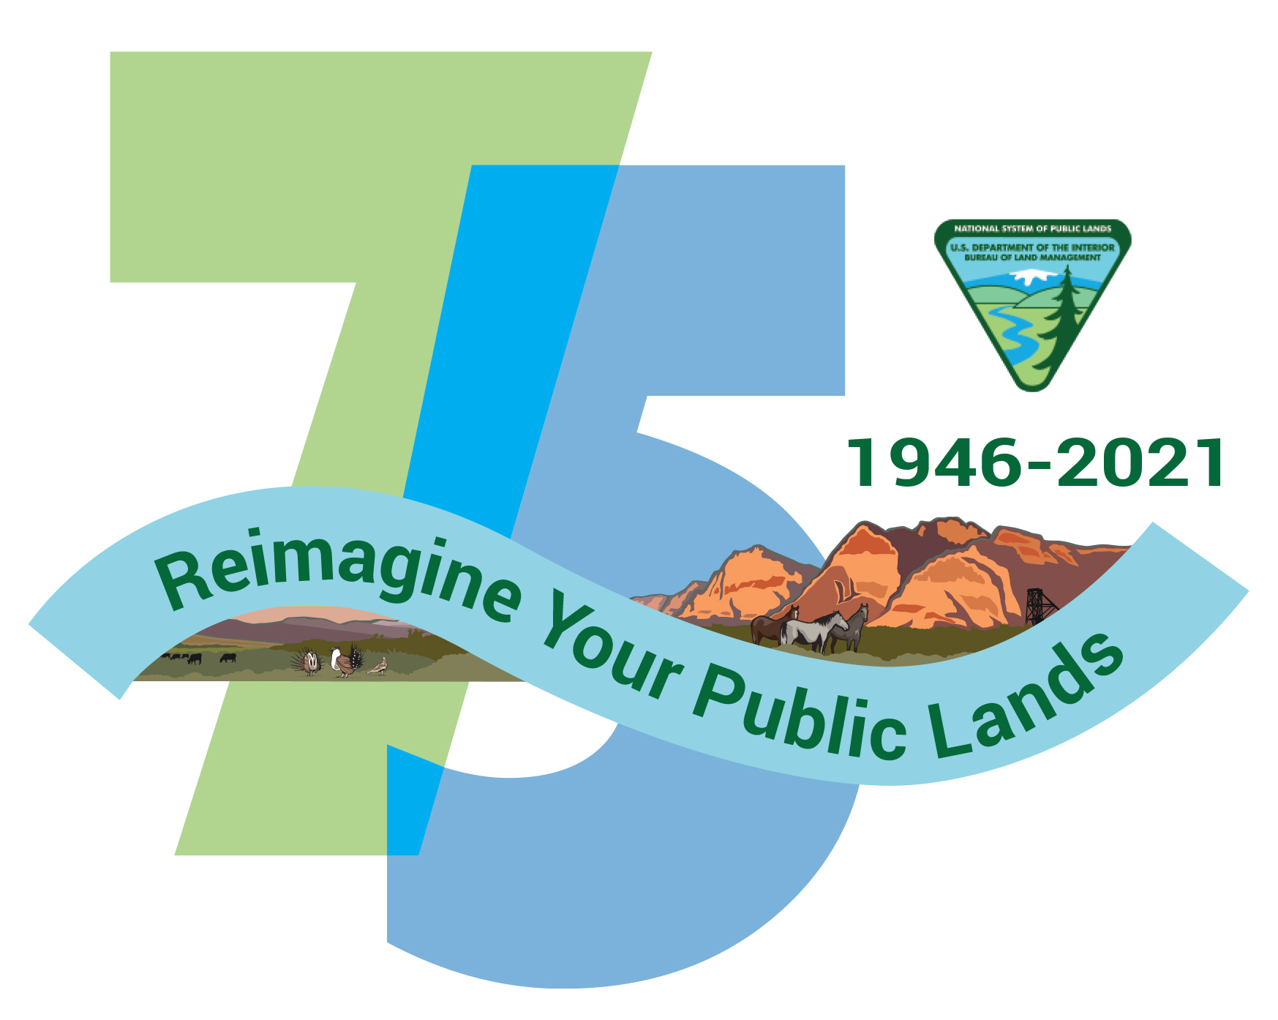

Speaker: Chris Tollefson, Division Chief of External Affairs, Bureau of Land Management
Topic: BLM’s 75th Anniversary
Date: January 10, 2022
Time: 12:15 - 1:15 pm (Eastern)
Webcast Only: Microsoft Teams Live Event (You can also use this link to access the recorded seminar after the event.)

Closed captioning (CC) is available. Click the CC button on the Teams viewer.

In 2021, the Bureau of Land Management (BLM) commemorated two milestone events: the 75th anniversary as an Interior Department agency and the 45th anniversary of the Federal Land Policy and Management Act of 1976 (FLPMA), the principal law defining BLM’s mission. Please join the Office of Policy Analysis to learn how BLM continues to evolve and adapt to the nation’s changing needs from its public lands.

To view the Live Event, please click on the link above. Join 5-10 minutes early to avoid technical difficulties.

To view the recorded event, please click on the link above (following the event).

The public is welcome to join the Microsoft Live (or recorded) event.

For Interior Department Registrants Only: This seminar meets one hour of Executive Education training. To document your attendance, pre-register via DOI Talent. Be sure to return to DOI Talent to mark yourself complete after you have attended the seminar.

For additional information about this event, please contact Malka Pattison at: malka_pattison@ios.doi.gov

