Interior’s Office of Policy Analysis Seminar:
Dam Removal: Reflection on Experiences and New Tools

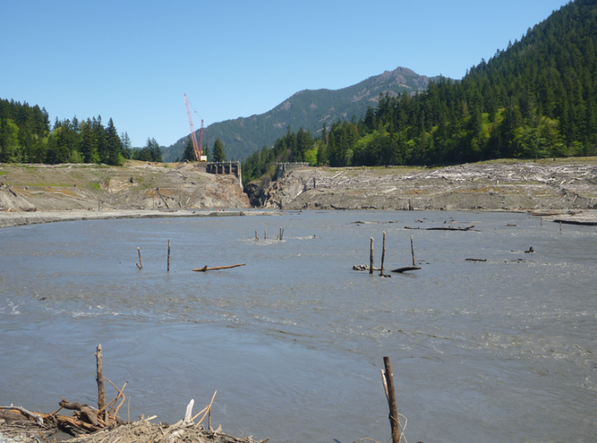
Photo Caption: Looking downstream at Glines Canyon Dam removal on the Elwha River, WA.

Moderator: Benjamin Simon, Retired Chief DOI Economist, DOI Office of Policy Analysis
Panelists:
- Jeff Duda, Research Ecologist, U.S. Geological Survey
- Benjamin Simon, Retired Chief DOI Economist, DOI Office of Policy Analysis
- Todd Gaston, Economist, Bureau of Reclamation
- Matt Collins, Environmental Scientist, NOAA Fisheries
- D.J. Bandrowski, Senior Project Engineer, Yurok Tribe
- Jennifer Bountry, Hydraulic Engineer, Bureau of Reclamation
- Tim Randle, Hydraulic Engineer, Bureau of Reclamation

Topic: Dam Removal: Reflection on Experiences and New Tools
Date: August 8, 2022
Time: 12:15-1:45 pm (Eastern)
Webcast Only: Microsoft Live Event (You can also use this link to access the recorded seminar after the event.)

Closed captioning (CC) is available. Just click the CC button on the Teams viewer.

Dams are a vital resource to ensure our nation’s ability to, among other services, deliver municipal and industrial water, supply water for irrigated agriculture, reduce flooding, generate hydropower, provide recreation opportunities, and maintain aquatic habitat in reservoirs. However, some dams have reached the end of their useful service life or can be replaced with streamside infrastructure to meet water delivery needs. Dam removal is an important tool for ecosystem restoration, with projects improving safety, restoring migratory fish passage, and enhancing aquatic and terrestrial habitat within the river corridor. This webinar will provide an overview of resources to track dam removal happenings, how to approach economic considerations related to dam removal, and highlight new technical guidelines on dam removal planning. The webinar will address small and large dam removals with lessons learned from implementation and monitoring.

For more information, please visit these websites:
www.doi.gov/restoration
https://www.sciencebase.gov/drip/
https://www.ussdams.org/resource-center/publications/white-papers/
https://acwi.gov/sos/pubs/dam_removal_analysis_guidelines_for_sos_final_vote_2017_12_22_508.pdf
www.americanrivers.org

The Public is Welcome to join the Microsoft Live (or recorded) event.

For Interior Department employees seeking training credits: This seminar meets one hour of Executive Education training. To document your attendance, preregister via DOI Talent. Be sure to return to DOI Talent to mark yourself complete after you have attended the seminar.

For additional information about this event, please contact Malka Pattison at: malka_pattison@ios.doi.gov

