DOI Office of Policy Analysis Seminar
Promoting Prosperity and Resiliency for Tribal Nations: the White House Council on Native American Affairs
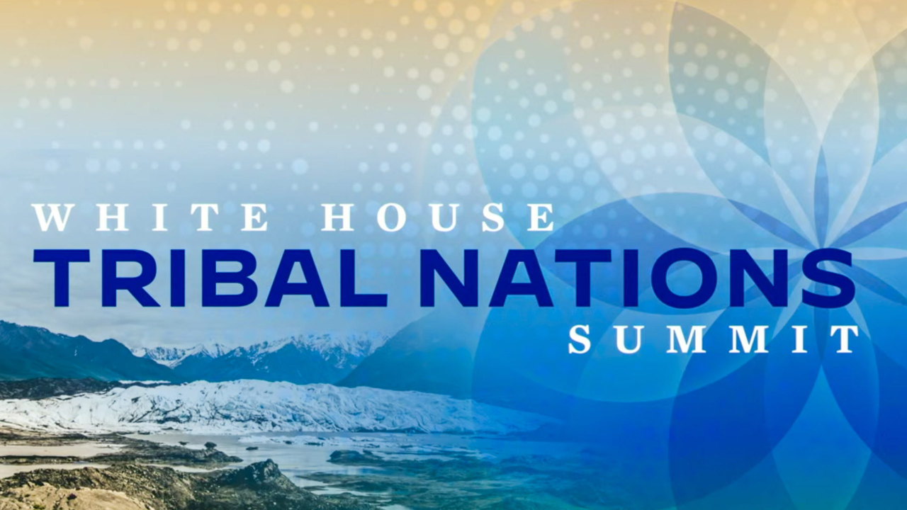
Speaker: Anthony Morgan Rodman, Executive Director, White House Council On Native American Affairs
Topic: Promoting Prosperity and Resiliency for Tribal Nations: White House Council on Native American Affairs
Date: Monday, December 12, 2022
Time: 12:15pm – 1:15pm (Eastern)
Webcast ONLY: Microsoft Live Event (You can also use this link to access the recorded seminar after the event)
Closed captioning (CC) is available by clicking the CC button on the viewer that comes up on Teams.
The White House Council on Native American Affairs (WHCNAA) mobilizes over twenty Federal agencies to act as one inter-agency body to promote prosperity and resiliency for Tribal Nations. The WHCNAA is co-chaired by Secretary of the Interior Deb Haaland and the Director of the White House Domestic Policy Council Ambassador Susan Rice. Discover how to break down bureaucratic siloes to improve delivery of services to Tribal Nations. Explore how the Federal Trust Responsibility to Tribes applies to all Departments and Agencies, and how the U.S. Government can better uphold that responsibility.
To view the Live Event, Click on the link above. Join 5-10 minutes early to avoid technical difficulties.
To View the recorded event, click on the link above (following the event).
The public is welcome to join the Microsoft Live (or recorded) Teams Event.
For Interior Department registrants seeking training credits: This seminar meets one hour of Executive Education training. To document your attendance, preregister via DOI Talent. Be sure to return to DOI talent to mark yourself complete following the seminar.
For additional information about this event, please contact Malka Pattison

