Interior’s Office of Policy Analysis Seminar
Women’s Suffrage in Black and White

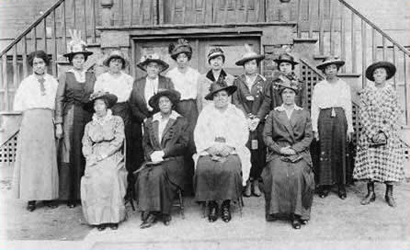
Phyllis Wheatley Club, Buffalo, NY. Nannie Hellen Burroughs Collection, Library of Congress

Speaker: Susan Philpott, Park Ranger, Belmont-Paul Women’s Equality NM, National Park Service (NPS)
Topic: Women’s Suffrage in Black and White
Date: February 14, 2022
Time: 12:15 - 1:15 pm (Eastern)

Webcast Only: Microsoft Teams Live Event (You can also use this link to access the recorded seminar after the event.)
Closed captioning (CC) is available. Click the CC button on the Teams viewer.

August 2020 marked the 100th anniversary of the final ratification of the Nineteenth Amendment to the Constitution. The amendment reads, “The right of citizens of the United States to vote shall not be denied or abridged by the United States or by any state on account of sex.” The fight for women’s suffrage lasted for over seven decades. African American women joined the struggle for women’s equality from its earliest days but often found themselves pushed aside and marginalized by white suffragists. The National Park Service commemorated the centennial of women’s enfranchisement, one of the most significant expansions of democracy in the nation’s history, while recognizing this difficult aspect of the story. Join Park Ranger Susan Philpott for a discussion about the role of African American women in the struggle for women's suffrage, as we examine the erasures and silences of history. For more information, visit the NPS 19th Amendment subject site and the article “African American Women and the Nineteenth Amendment” by Sharon Harley.

To view the Live Event, please click on the link above. Join 5-10 minutes early to avoid technical difficulties.

To view the recorded event, click on the link above (following the event).

The Public is Welcome to join the Microsoft Live (or recorded) Teams Event.

Interior Department employees seeking training credits: This seminar meets one hour of Executive Education training. To document your attendance, preregister via DOI Talent. Be sure to return to DOI Talent to mark yourself complete following the seminar.

For additional information about this event, please contact Malka Pattison

