Statement of Dr. Murray Hitzman,
Associate Director for Energy and Minerals, U.S. Geological Survey
U.S. Department of the Interior
before the
House Committee on Natural Resources
Energy and Mineral Resources Subcommittee
on
July 20, 2017

Good morning Chairman Gosar, Ranking Member Lowenthal, and Members of the Subcommittee. Thank you for the opportunity to discuss the Nation’s mineral resources.
Background
On behalf of the U.S. Department of the Interior, the U.S. Geological Survey (USGS) is responsible for collecting data and conducting research on a wide variety of mineral resources. Research is conducted to understand the geologic processes that have concentrated known mineral resources at specific locations in the Earth’s crust; and to assess quantities, qualities, and areas of undiscovered mineral resources, or potential future supply. The USGS maintains a workforce of geoscientists, including geologists, geochemists, geophysicists, and resource specialists, with expertise in minerals and materials. These geoscientists continuously collect, analyze, and disseminate data and information on domestic and global rare earth and other mineral reserves and resources, production, consumption, and use.
Current Understanding of the Nation’s Mineral Endowment
Domestic and global demand for mineral commodities continues to rise. Mineral commodities have ever more applications in both consumer and national security products, especially those products involving advanced technologies. The United States remains a major mineral producer with an estimated total value of non-fuel mineral resources of $75.6 billion, and is a net exporter of 16 non-fuel mineral commodities. However the country also is increasingly reliant on foreign sources for processed mineral materials. In 2016, imports made up more than one-half of the U.S. apparent consumption of 50 non-fuel mineral commodities (valued at $32.3 billion), and the United States was 100% import reliant for 20 of these mineral commodities (valued at $1.3 billion), including 8 critical minerals as identified by the USGS. This is an increase from 47 non-fuel mineral commodities on which the country was more than one-half dependent in 2015 and 19 non-fuel commodities for which the country was 100% import reliant in 2015. China, followed by Canada, supplied the largest number of non-fuel mineral commodities to the U.S. in 2016, similar to 2015.
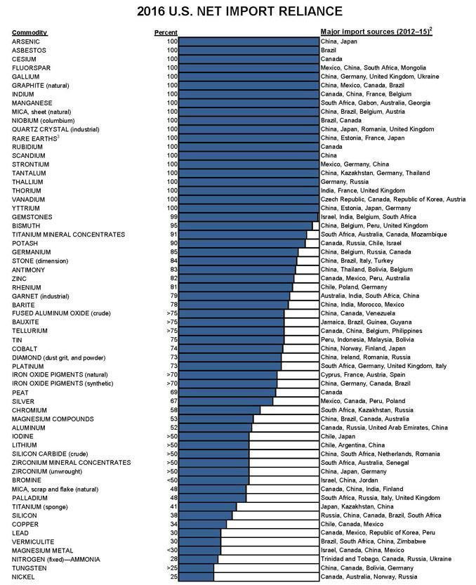

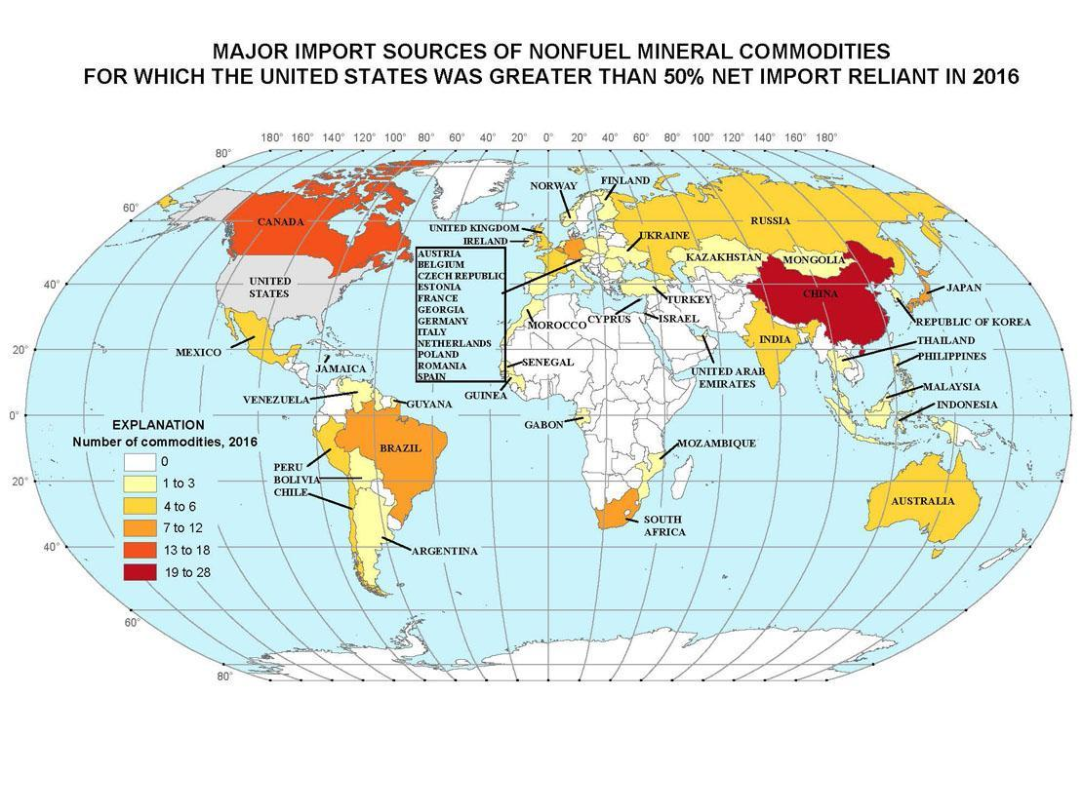
USGS mineral commodity specialists study current production and consumption for 84 mineral commodities, both domestically and internationally for 180 countries. These production and consumption data include information on domestic production and use, import sources, world production capacity, and recycling. The data allow for a comprehensive understanding of the complete life cycle of mineral resources and materials. This information is published annually in the USGS Mineral Commodity Summaries (USGS, 2017) and includes a description of current events, trends, and issues related to supply and demand. These data inform analyses and policies concerning the Nation’s dependence on foreign sources of mineral commodities.
In addition to providing information on mineral production and consumption, the USGS also produces data that aids in assessing the mineral potential of the country, which we have done since 1879. This work continues as different mineral commodities gain importance for the economy and as our understanding improves of how mineral deposits form and how they can be discovered. Geological maps are a primary source of information for mineral exploration. Many USGS geological maps are produced in conjunction with state geological surveys through the National Cooperative Geologic Mapping Program through cooperative agreements.
The Mineral Resources Program (MRP) conducts research to better understand new types of critical mineral deposits. Also critical are geological mapping and geophysical data. These USGS research and assessment products are crucial to Federal, state, tribal, and industry decision-making on mineral resources management.
Potential to Enhance the Nation’s Mineral Resources Information
The United States remains a major mineral producer. The Nation’s lands undoubtedly contain additional deposits of critical and strategic minerals, but mineral exploration by the private sector is hampered by the lack of modern geological and geophysical data. USGS studies of domestic mineral resources make heavy use of geologic mapping and the production of regional scale geophysical maps such as aeromagnetic and radiometric maps that help define areas favorable for exploration.
Currently less than one-third of the United States has complete topographic, geologic, and geophysical 3D mapping at fine enough scales to support these resource assessments that directly support private industry exploration. For example, Alaska and large portions of the Midcontinent (IL, IN, IA, KS, MI, MN, MO, NE, OH, OK, and WI) represent some of the most prospective ground for mineral discovery in the world. However, the favorable rocks for the deposits are buried and not visible at the Earth’s surface, and have not been more specifically identified through modern geological and geophysical mapping. Other countries such as Canada and Australia have undertaken such geological and geophysical surveys nationwide and have reported that investments of one dollar by the government have resulted in further investment of over five dollars by the private sector.
In addition to reinvesting in the Nation’s fundamental data on mineral resources, an accurate assessment of the Nation’s mineral resources must include not only the resources available in the ground but also those that become available through recycling. Metal supply consists of primary material from a mining operation and secondary material, which is composed of new and old scrap. Metals show a wide range of recycling rates, recycling efficiency, and new-to-old-scrap ratios. Recycling rates cluster in the range from 15 to 45 percent for different resources. Although recycling is a major source of some non-fuel mineral resources such as aluminum, technical difficulties with recycling mean that for other mineral commodities such as the rare earth elements recycling is challenging. USGS compiles information about recycling, but research on new methods of metal recycling is undertaken mainly by the Department of Energy.
Conclusion
The Department, through the USGS, fulfills its role as the federal provider of unbiased research on known mineral resources, assessment of undiscovered mineral resources, and information on domestic and global production and consumption of mineral resources for use in global mineral supply chain analysis.
Thank you for the opportunity to present on behalf of the Department on the important subject of mineral resources. I will be happy to answer any questions.

for Canada: Duke, J.M., 2010, Government geoscience to support mineral exploration: public policy rationale and impact: Prospectors and Developers Association of Canada. Toronto, Canada, 64 p. for Australia: ACIL Allen Consulting, 2015, Exploration Incentive Scheme Economic Impact Study, Geological Survey of Western Australia, 78p.

